|  |  |  |  |  |  |
| --- | --- | --- | --- | --- | --- |
| Date | 9-Dec-22 | | | Tester Name | Mohammad Yusuf |
| Environment | Penfax - Test | | | Login used |  |
| Operating System | Windows | Version: | Update: | | |
| Software Used | Select Software | Version: | Update: | | |
| Select Software | Version: | Update: | | |
| Release version |  | | | | |
| Title |  | | | | |
| Test Type | Regression | | | | |
| Test Scenario |  | | | | |
|  |  | | | | |
| Expected Results |  | | | | |
| Pass/Fail | Select | | | JIRA# | N/A |

Describe your steps with screenshots:

In PENFAX5 do a search for the member

Click on the Stakeholder ID

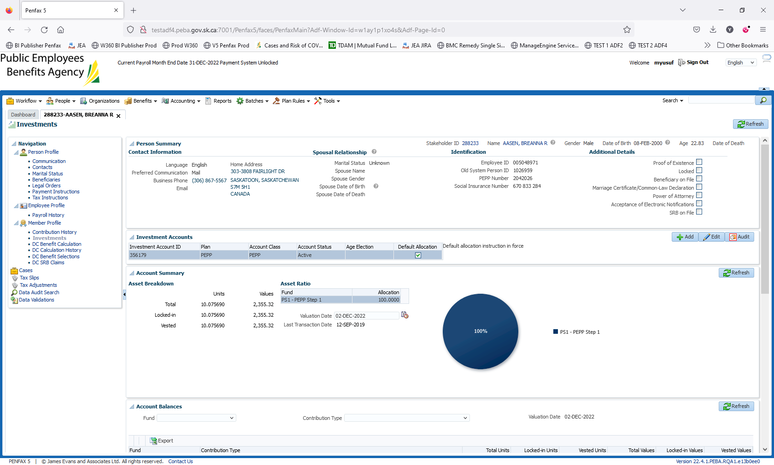

Click on DC Benefit Selection

Click ADD

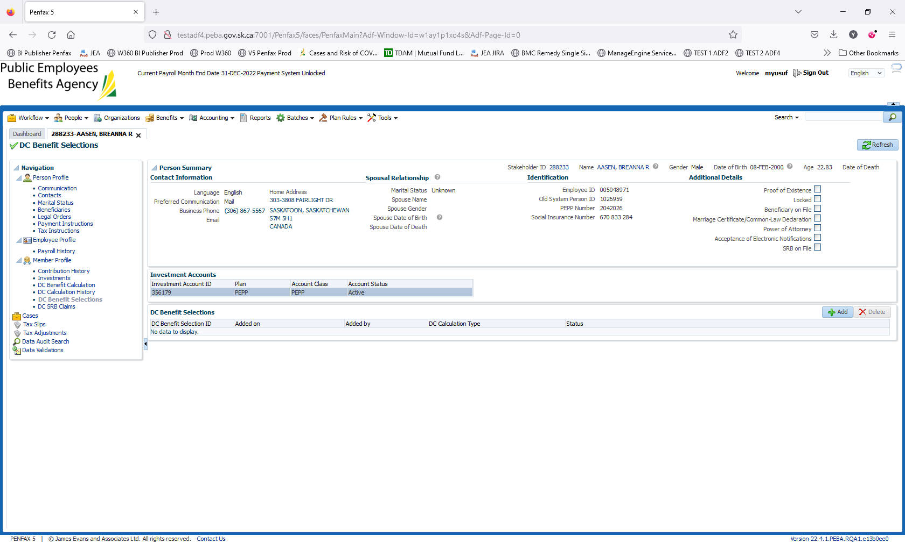

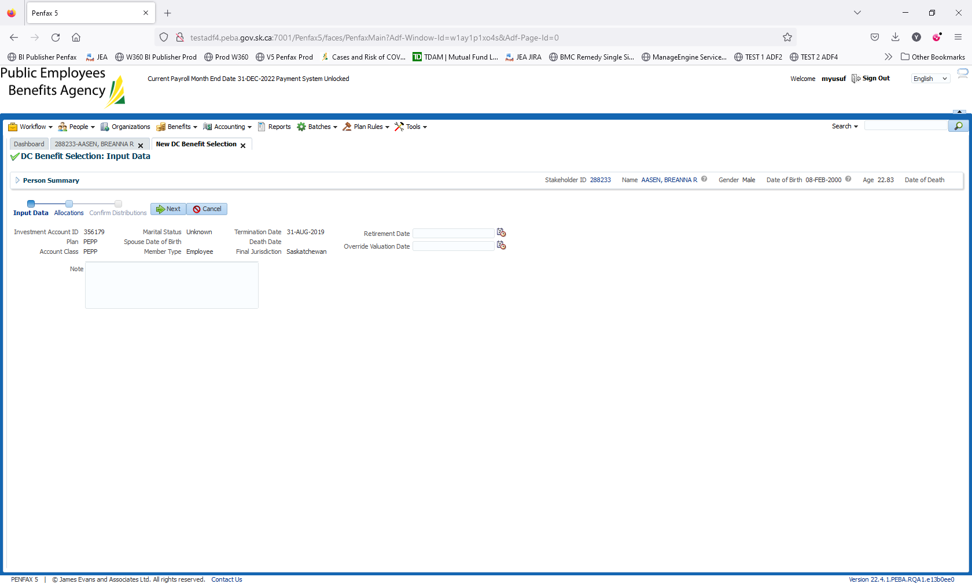

Click on next

Under Allocations Click +Add

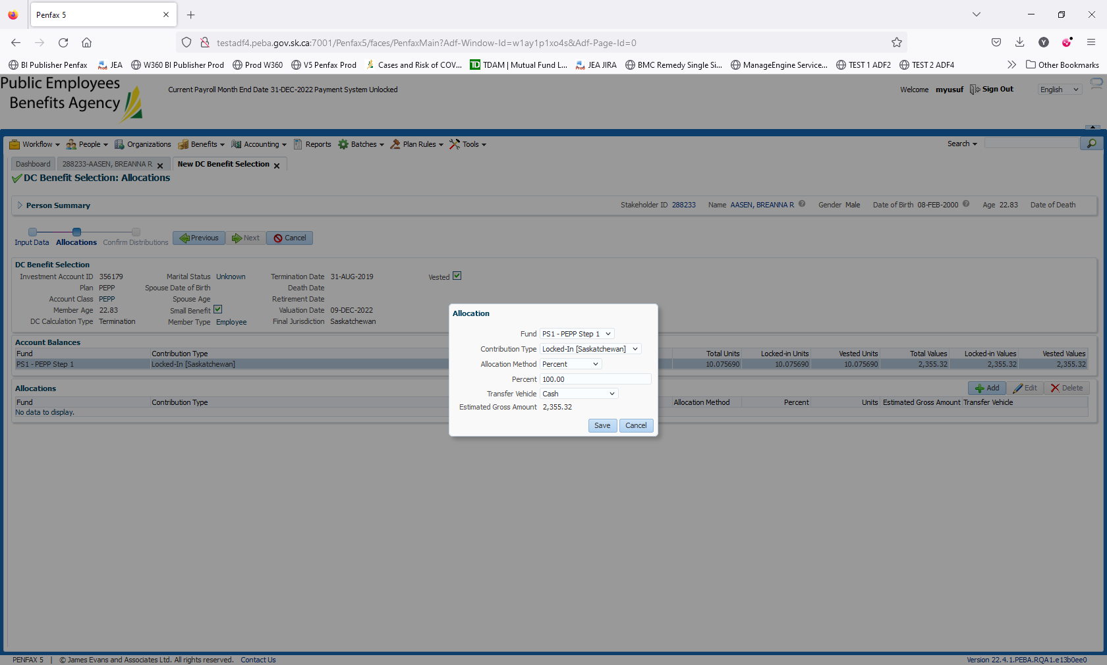

Fund select a fund

Contribuiton Allocation Select one fo the options

Allocation Method change to %

Percent enter 100

Transfer vehicle select cash

Click Save

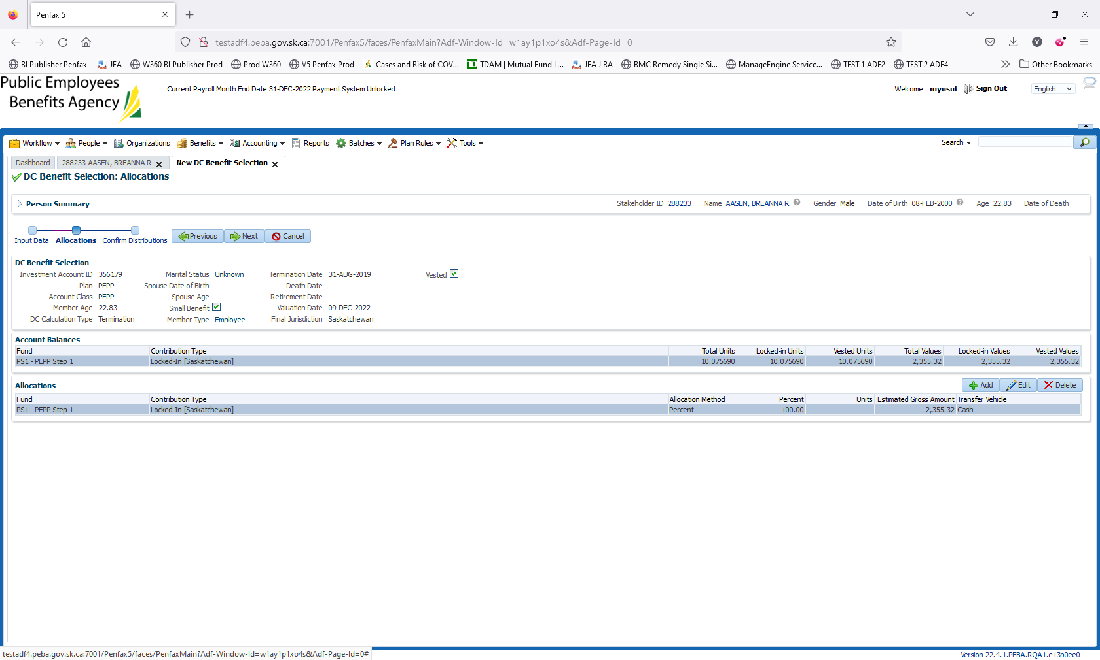

Click next on the train

Input a Payment Instruction

Input a Tax Instrucion

Click Submit for Approval

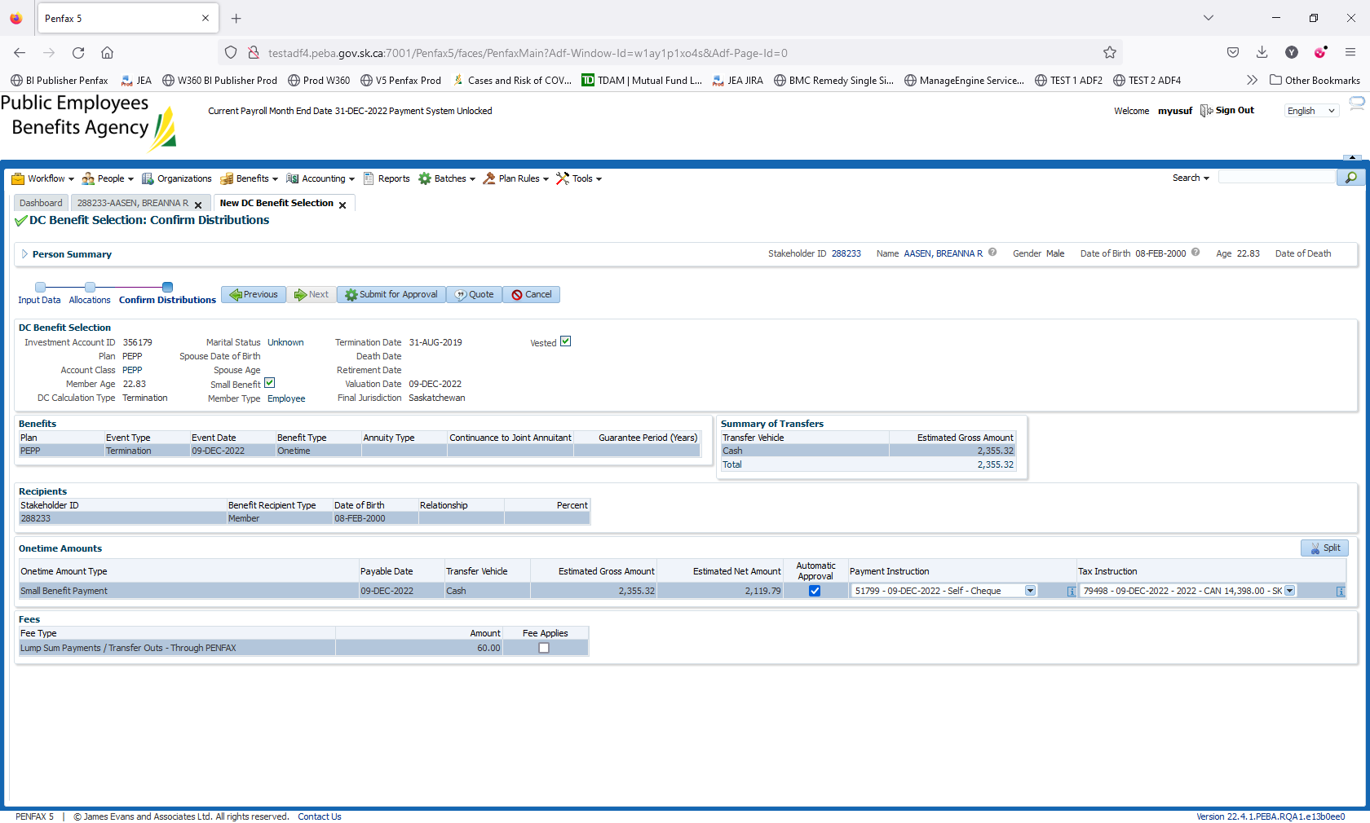

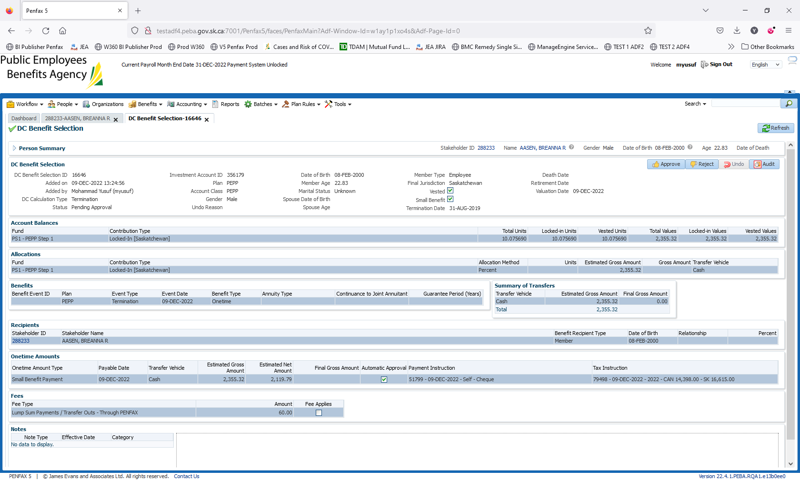

Hit Approve

When the new box opens hit save

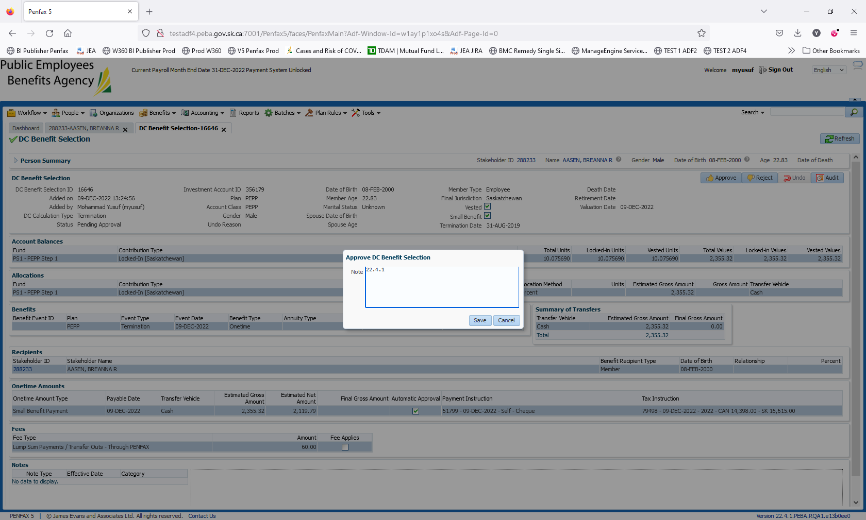

Wait for overnight batch processes to run

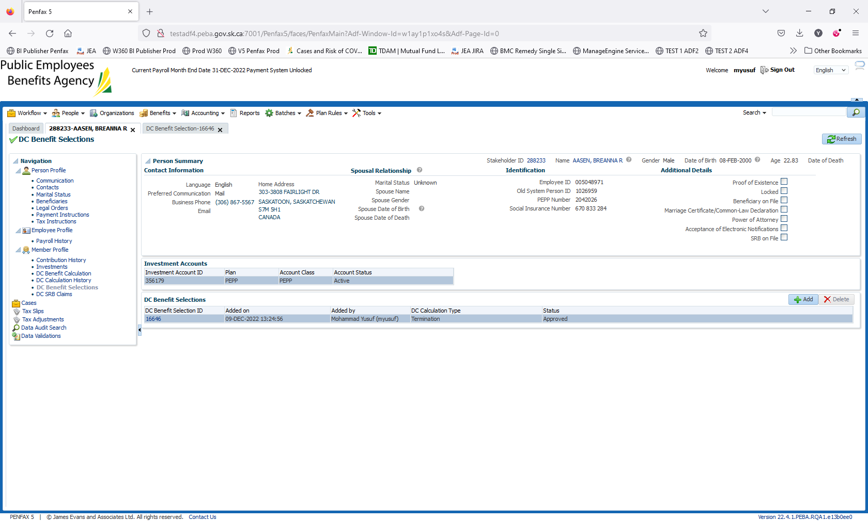

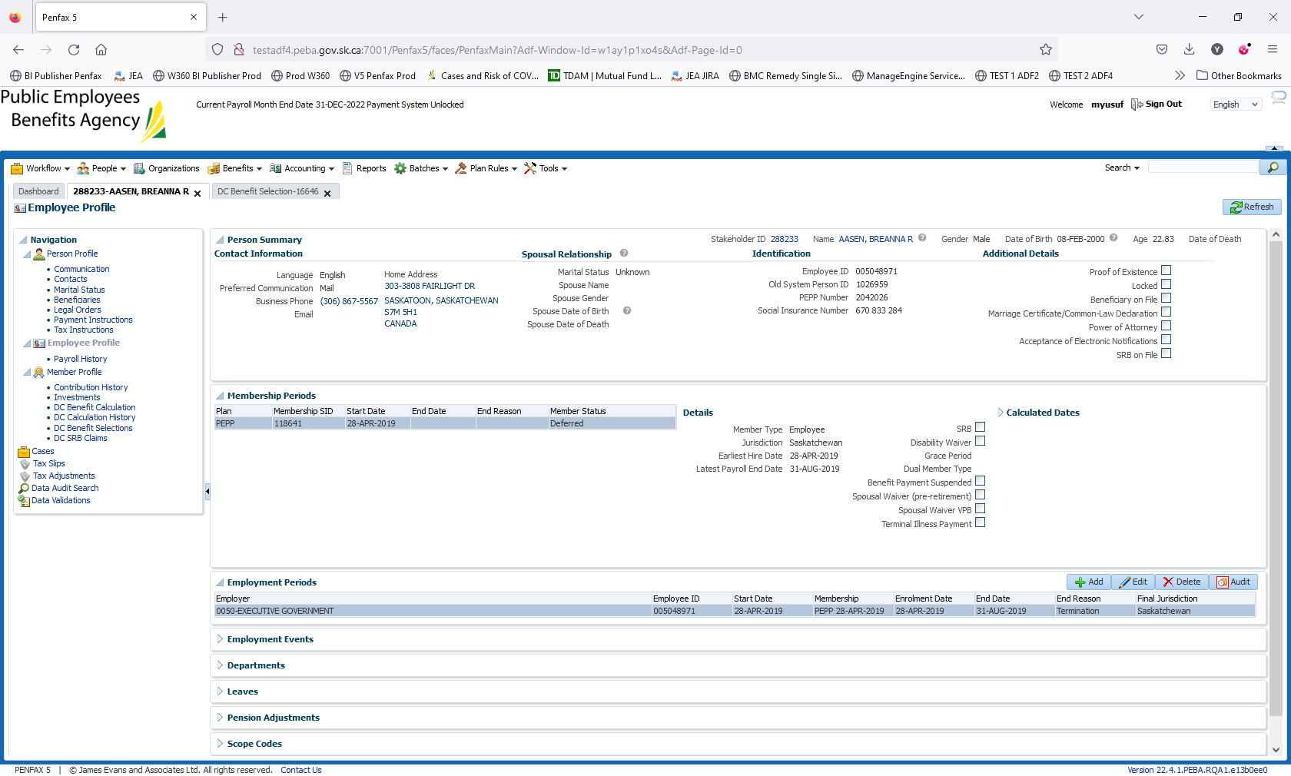

Wait for overnight batch processes to run

Results as Expected

